IFG Challenge 3rd Year

Three Week Programme

Physical Fitness Physical
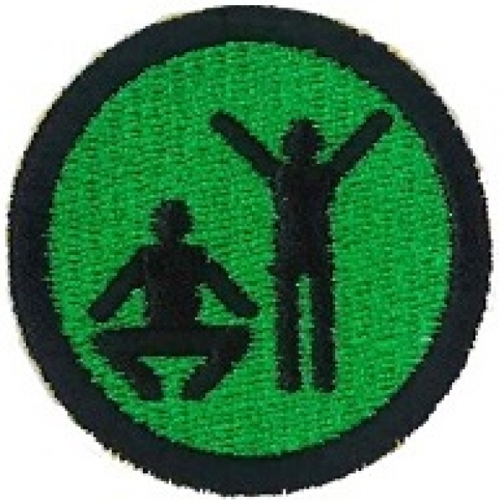

Aim:
The Aim for this three week programme is to try new ways of exercising and to have fun doing so

Objectives:
- To try different types of exercising to music using an instructor/CD or DVD
- To try several types of exercise, these could include:
Zumba
Aerobics
Pilates
Wii Sports
Kick boxing
Body pump (gym)
Body Balance
Latin Dancing – Rumba, Samba
RocknRoll
Salsa
- To learn why it is important to exercise
- To have fun

There are several ways you can do this programme.
- You could have an instructor come to your venue (They would need to use a CD)
- Go to a local gym
- Use a DVD (if you don’t have any they can be purchased from “The Warehouse” or any DVD store)
- Check out the internet if you can’t find someone to take the sessions as there are ideas available on youtube – check this link out for beginner Zumba
http://www.youtube.com/watch?v=oDwK324I0A8&feature=related

Teaching Sessions:
You can choose to run one activity for the whole three weeks, or you could choose a different one for each week, thus exposing to the girls to different forms of physical activities.

.
Preparation:
Depending on which option you are using the preparation will be different.
- Advise girls what they need to wear.
- If you have an instructor coming to your venue check what they need you to supply
- If you are going to a local gym you will need to arrange transport and complete the necessary forms for going off site.
- If you are going to use a DVD at your own venue you will need either a DVD player and TV or a data projector, computer and large screen
- You may need to arrange for someone to thank the instructor and present with small gift.
Devotions:
Depending on how you are doing this topic you may or may not be able to take a full devotional session. If not make sure that you include a prayer time at an appropriate moment either at the beginning or end of the evening.
Use the verse below as a basis to discuss the importance of looking after the bodies God gave us. End the devotion with a prayer.

Psalm 139:14" I praise you because I am fearfully and wonderfully made; your works are wonderful, I know that full well."

David looks at his body with the eyes of faith and says "I am fearfully and wonderfully made".
This is something many of us struggle with.
You can look at your skinny body and distinct lack of muscles and feel that you have missed out in the beauty stakes.
If you read about artificial intelligence and computer programming you will realize that our arms are a marvel that no robot arm can match, our eyes are wonders no camera can ever come close to. Our ability to walk over all kinds of terrain, ride bicycles, climb cliffs and swim through water is not matched by any vehicle that man has made despite billions of dollars of research.
And with our nervous systems we all got a free multi-media super-computer with self-programming capacity! At birth! For free, Unearned!
Our first degree was in chemistry, and the ability of the liver to synthesize complex macromolecules out of last night’s dinner is mind-boggling. No chemist can go anywhere near it.

Coaches Tip:
Using an instructor or going to the gym could incur a small charge.
Also may be a good opportunity to have mums along to this session as well.

Notices & home time:
Notices will need to be sent home if you are going off site with the details. The girls will also need to be told what clothing is appropriate for this activity.

